LAB ASSIGNMENT-(5.4)
AI ASSISSTED CODING Hall.tno: 2303A51685
B.Tno: 13
Task Description #1:
• Prompt GitHub Copilot to generate a Python script that collects user data (e.g., name, age, email). Then, ask Copilot to add comments on how to anonymize or protect this data.
Prompt:
#Generate a Python script that collects user name, age, and email.
#Add inline comments explaining how to protect or anonymize sensitive data,
#such as hashing emails and avoiding unencrypted storage.
#Follow responsible and ethical coding practices.
Code:
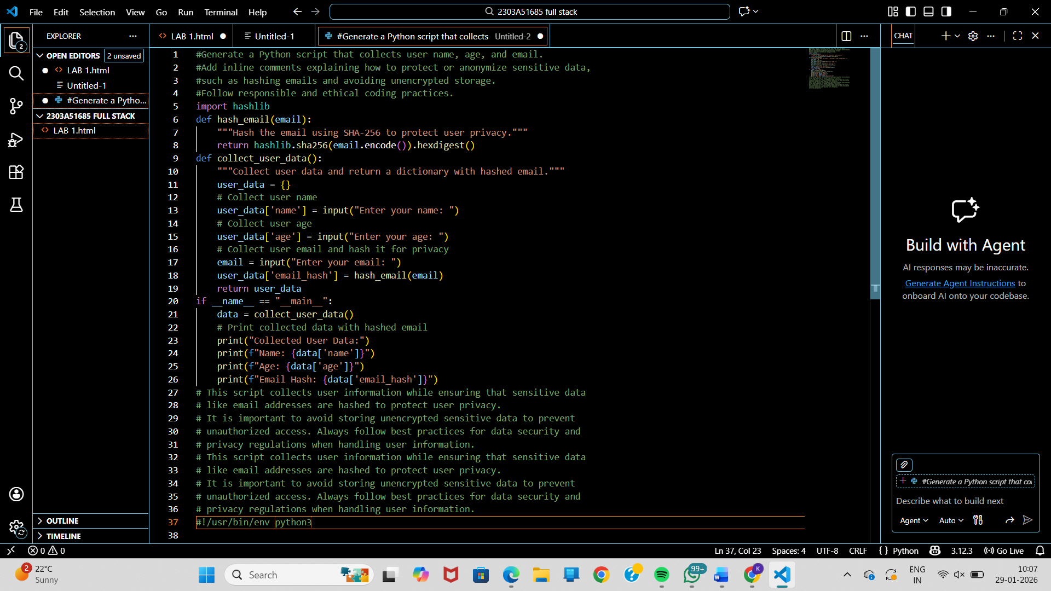
Output:

Justification:
This task demonstrates responsible handling of user data by protecting sensitive information such as email addresses through hashing. It avoids storing personal data in unencrypted form, reducing the risk of data breaches. The approach follows ethical coding practices and data privacy principles.

Task Description #2:
• Ask Copilot to generate a Python function for sentiment analysis. Then prompt Copilot to identify and handle potential biases in the data
PROMPT:
Generate a Python function that determines the emotional tone of a given text. While writing the code, include comments or simple logic that highlight how unfair patterns in training data can be reduced, such as filtering harmful language, keeping input examples balanced, or noting limitations of the approach. Keep the implementation minimal and easy to understand
Code:
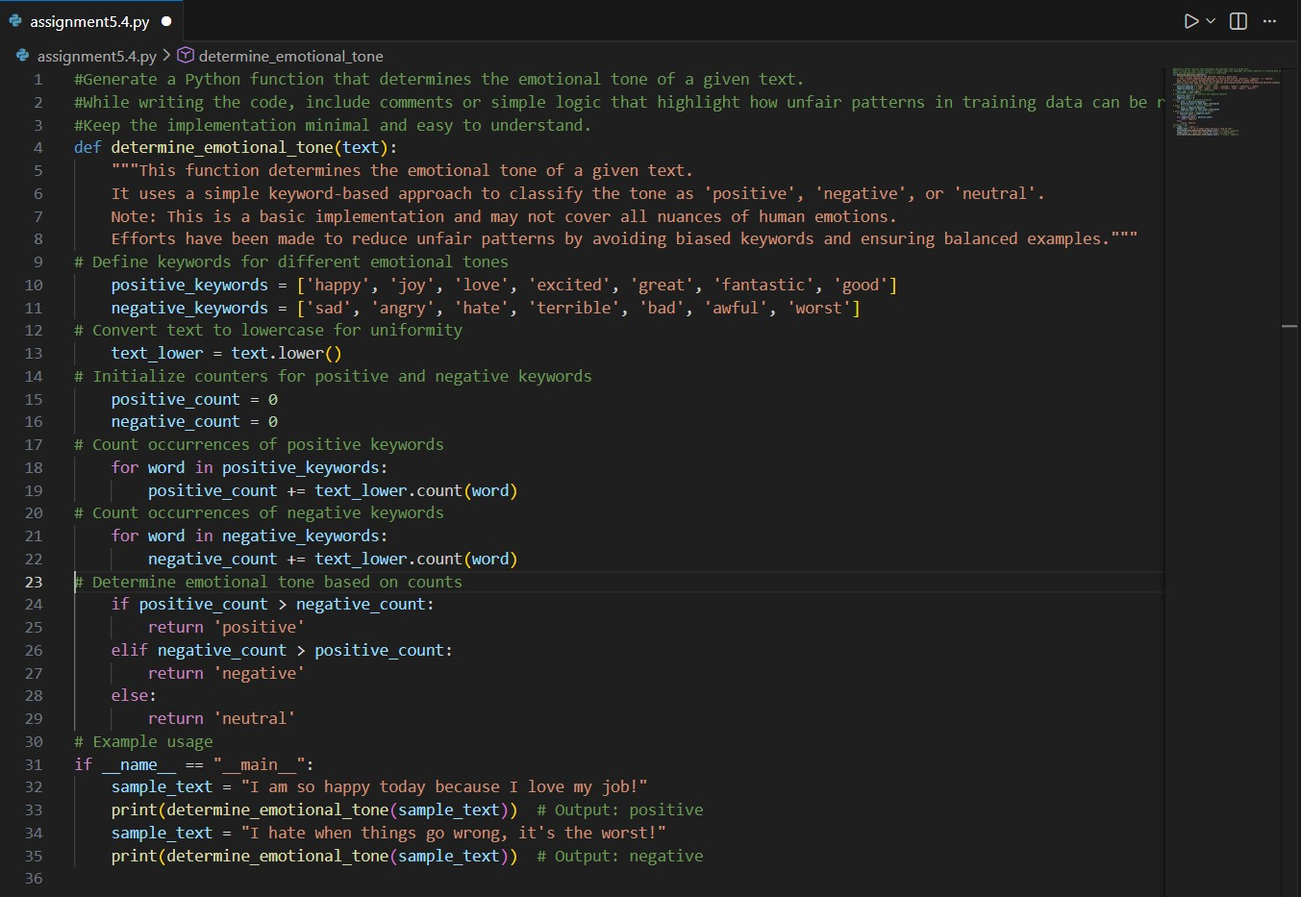
Output:
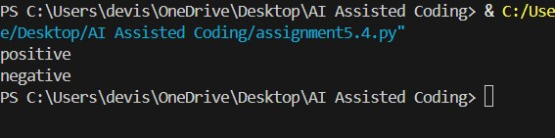
Justification:
This function uses a simple keyword-based approach, converting input to lowercase and counting predefined positive and negative words to classify tone as positive, negative, or neutral.
To reduce bias, it avoids offensive/identity-based terms and uses balanced keyword lists for positive and negative emotions.
It is a minimal, transparent, rule-based method and not a full ML model, keeping the logic easy to understand.
Task Description #3:
• Use Copilot to write a Python program that recommends products based on user history. Ask it to follow ethical guidelines like transparency and fairness
PROMPT:
Generate a simple Python program that recommends products based on a user’s purchase or browsing history. Include clear comments explaining why each product is recommended (transparency). Add basic fairness checks to avoid favoring only one brand or category. Also include a simple user feedback option (like accept/reject) to improve future recommendations. Keep the code minimal, readable, and ethically aligned.
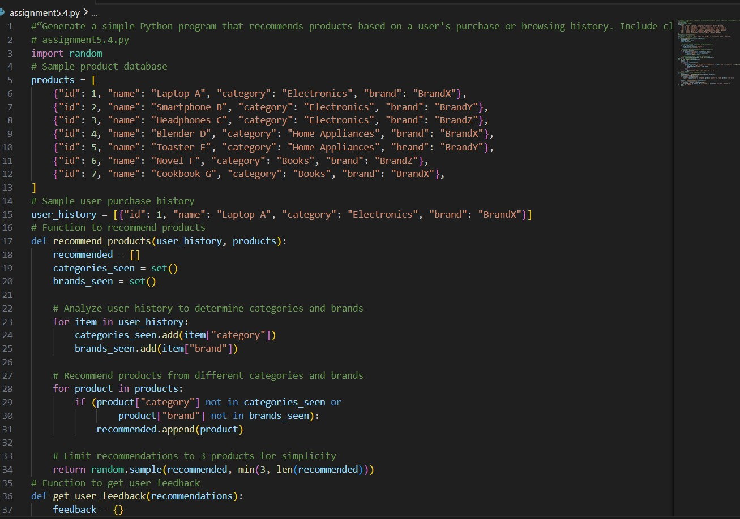
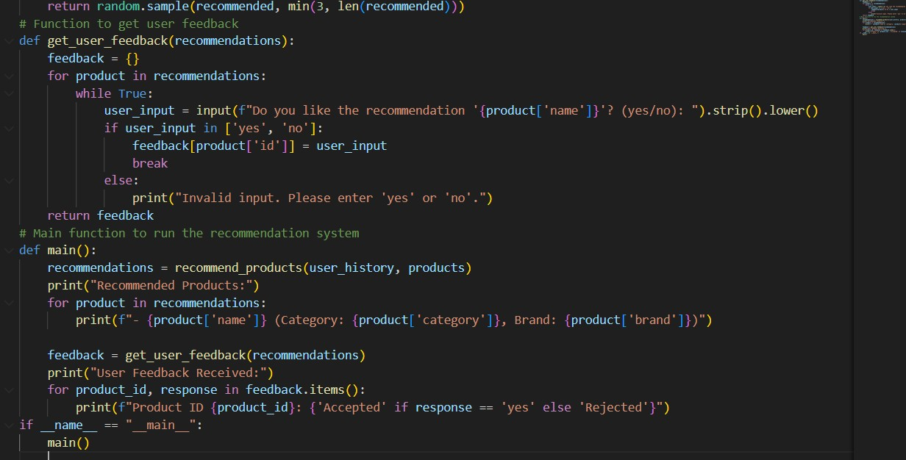
CODE:

OUTPUT: 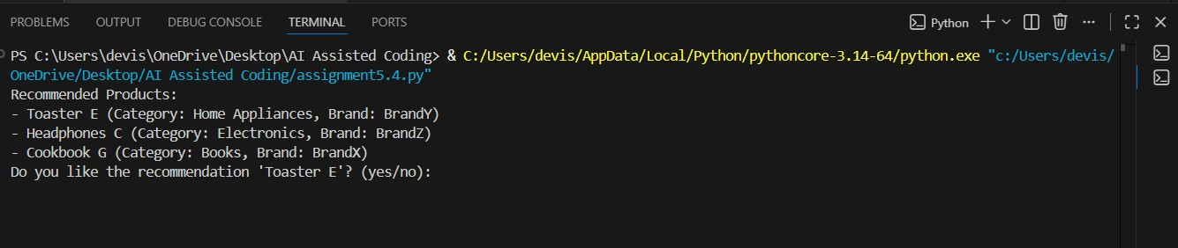
JUSTIFICATION:
Transparency is maintained by showing the product’s category and brand so users understand why it was recommended. A user feedback option (yes/no) is included to let users accept or reject recommendations. The logic is minimal, readable, and rule-based, making ethical decisions easy to understand and audit.

Task Description #4:
• Prompt Copilot to generate logging functionality in a Python web application. Then, ask it to ensure the logs do not record sensitive information.

PROMPT:
Generate Python logging functionality for a simple web application. Ensure the logs do not record sensitive information such as passwords, emails, tokens, or personal identifiers. Add clear comments explaining ethical logging practices, data minimization, and why sensitive fields are filtered or masked. Keep the code simple, readable, and secure

CODE:
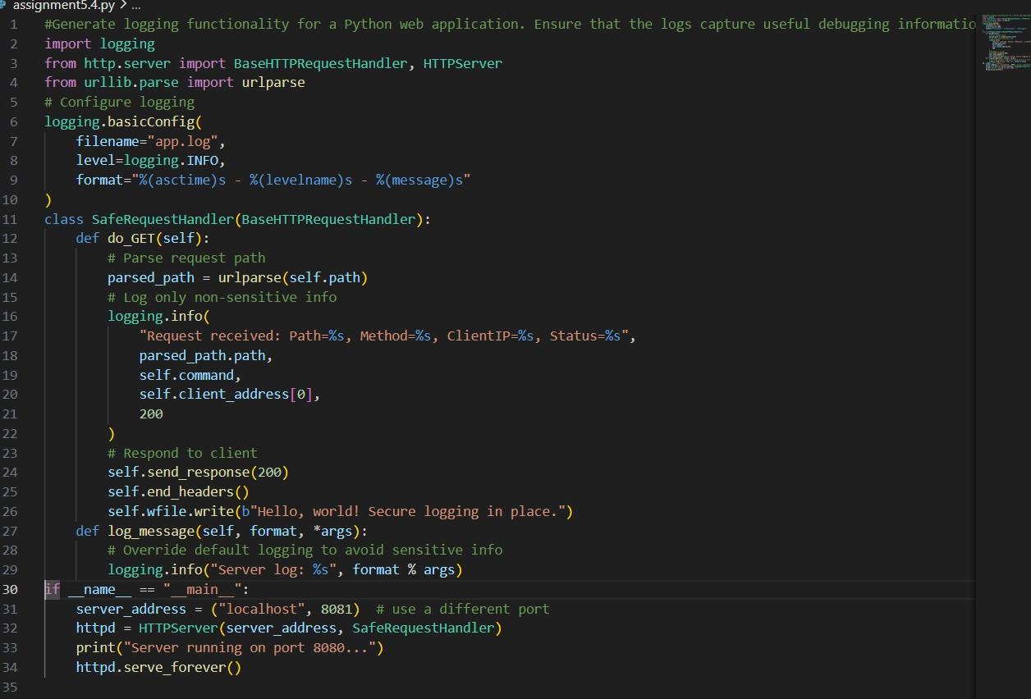
OUTPUT:
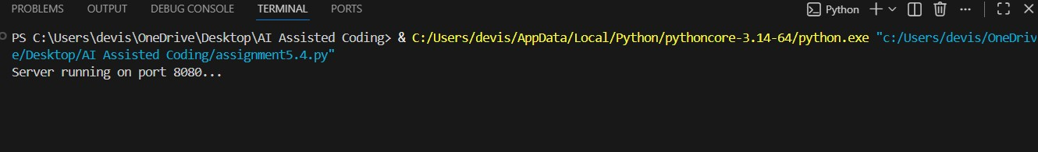
JUSTIFICATION:
This code sets up a simple HTTP server using Python’s http.server and logs requests with the logging module.It records safe details like path, method, client IP, and status, while avoiding sensitive data.Ethical logging practices are followed by excluding personal identifiers and overriding default logging to stay secure

Task Description #5:
• Ask Copilot to generate a machine learning model. Then, prompt it to add documentation on how to use the model responsibly (e.g., explainability, accuracy limits).
PROMPT:
Generate a simple machine learning model in Python (for example, a basic classifier using scikit-learn). Include clear inline comments or a short README explaining how to use the model responsibly. Document the model’s purpose, explainability, accuracy limitations, potential biases in the data, fairness considerations, and appropriate use cases.
CODE:
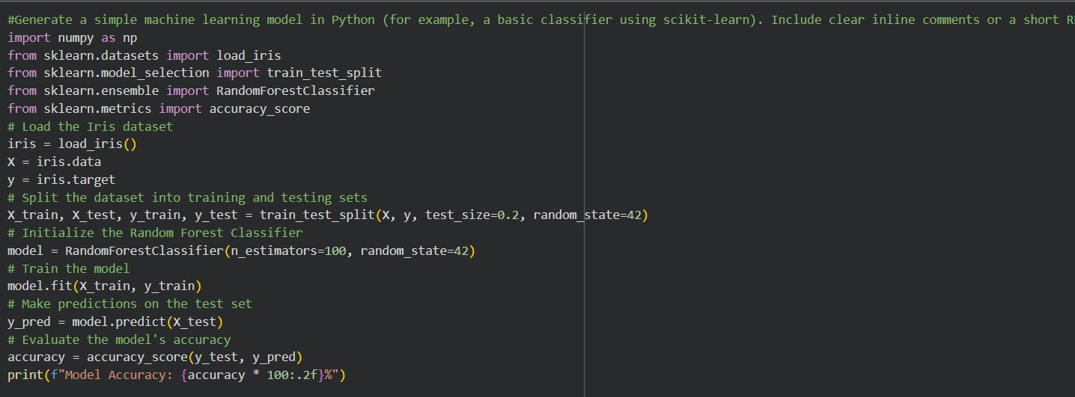
OUTPUT:
JUSTIFICATION:
This program builds a simple machine learning classifier using the Iris dataset. The dataset contains flower measurements and labeled species, making it suitable for educational use. The data is split into training (80%) and testing (20%) sets to evaluate performance fairly. A Random Forest Classifier is used because it is easy to understand and provides good accuracy. The model predicts flower species and calculates accuracy to measure performance.

